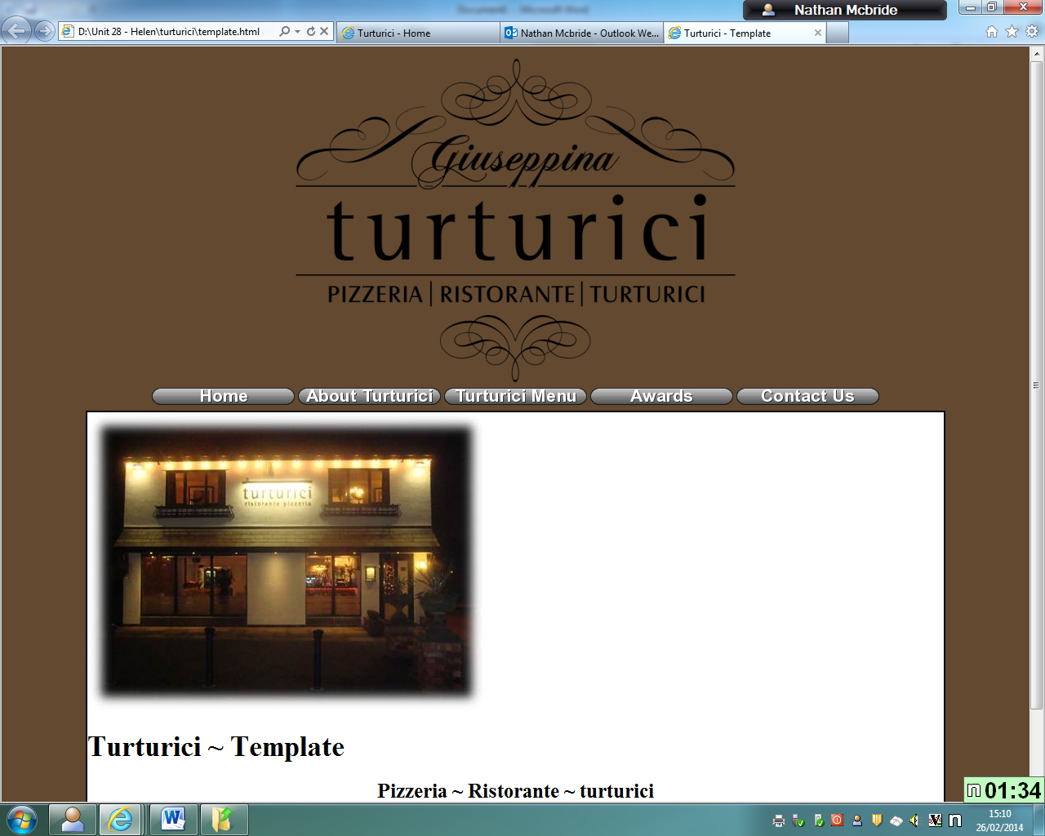

Before

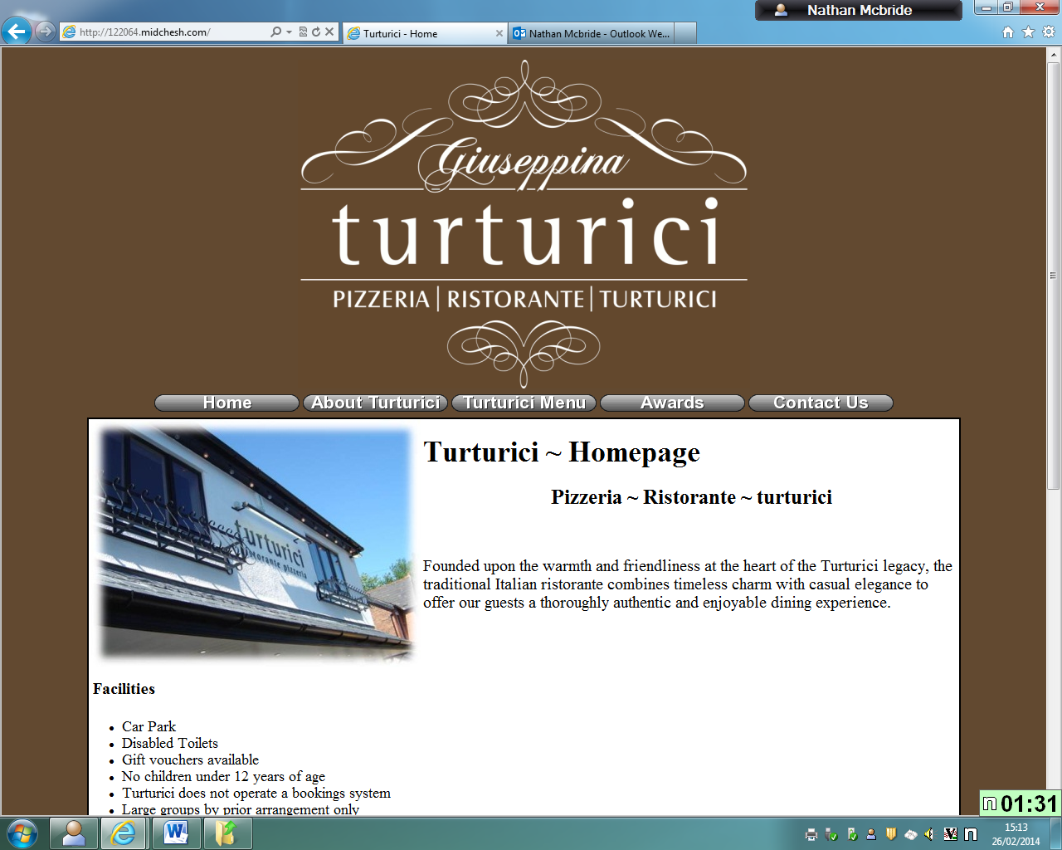

After

Though there is quite little difference from the old and the new, the changes really have brought the whole thing to life, it looks a lot more lively and beautiful in the after. I prefer the After a lot more for this small reason, it makes it look happier and so animation brings the whole thing to life.